**Assignment 5**

**1.find the sum of the array.**

Steps:

1.define array

2.intialize sum variable and store the value with 0

3.Loop through the array to and add each element to sum

4.print the sum

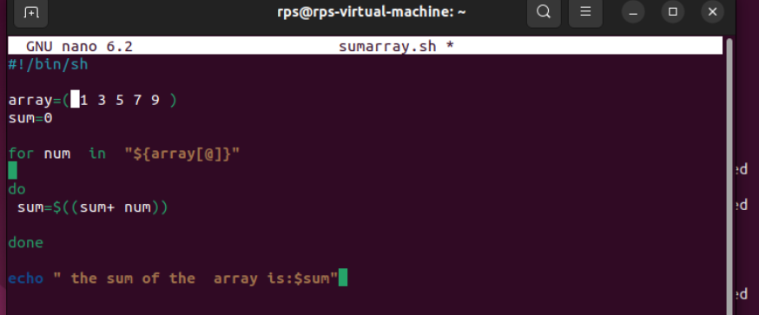

**Output:**

